ST. XAVIER’S COLLEGE

**Maitighar, Kathmandu**



**Computer Graphics**

**Lab Assignment #6**

**SUBMITTED BY:**

**Siddhant Rimal**

**013BSCCSIT039**

**SUBMITTED TO**

|  |  |
| --- | --- |
| **Er. Anil Sah**  **( Lecturer )** |  |
| **Department of Computer Science** | |

Submission Date: August 25th 2015

**OBJECTIVE 6.1: TO DRAW A ELLIPSE USING MID POINT ELLIPSE ALGOTHM**

|  |  |
| --- | --- |
| **Algorithm:** | |
| Step 1 | Start |
| Step 2 | Input radius rx and ry and ellipse’s centre (xc , yc ), and obtain the first point on ellipse  centered at origin as.  (xo, yo ) = (0,ry). |
| Step 3 | Calculate initial decision parameter value in Region1 as p10=ry2-rx2ry+1/4*rx2 |
| Step 4 | At each xk position, in Region1, starting at k=0, perform the tests:  Compute xk+1=xk+1  If p1k<0 next point to plot is  p1k+1=p1k+2ry2x+1  Otherwise, the next point along the circle is (xk+1,yk-1)  pk+1=pk+2xk+1+1-2yk+1  where, 2xk+1=2xk+2 and 2yk+1=2yk-2 |
| Step 5 | Determine symmetry point on the other seven octants |
| Step 6 | Move each calculated pixels positions (x,y) in to circle path centred at (xc,yc) as  x=x+xc, y=y+yc |
| Step 7 | Repeat Steps 4 through 6 until x>=y |
| Step 8 | Stop |

|  |
| --- |
| **//SOURCE CODE---------------------------------------------------------------------------** |
| #include <vcl\vcl.h> |
| #pragma hdrstop |
|  |
| #include "ellipse.h" |
| //--------------------------------------------------------------------------- |
| #pragma resource "*.dfm" |
| TForm1 *Form1; |
| int rx,ry,xc,yc,x,y,counter=0; |
| float pk; |
| //--------------------------------------------------------------------------- |
| __fastcall TForm1::TForm1(TComponent* Owner) |
| : TForm(Owner) |
| { |
| } |
| //--------------------------------------------------------------------------- |
| void __fastcall TForm1::EllipseDrawClick(TObject *Sender) |
| { |
| rx=StrToInt(RX->Text); |
| ry=StrToInt(RY->Text); |
| xc=StrToInt(XC->Text); |
| yc=StrToInt(YC->Text); |
| x=0; |
| y=ry; |
| pk=ry*ry-rx*rx*ry+1/4*rx*rx; |
|  |
| while((2*ry*ry*x)<(2*rx*rx*y)){ |
| //Region1 |
| Image1->Canvas->Pixels[xc+x][yc+y]=RGB(0,0,255); |
| Image1->Canvas->Pixels[xc-x][yc+y]=RGB(0,0,255); |
| Image1->Canvas->Pixels[xc-x][yc-y]=RGB(0,0,255); |
| Image1->Canvas->Pixels[xc+x][yc-y]=RGB(0,0,255); |
| x=x+1; |
| if(pk<0) |
| { |
| pk=pk+2*ry*ry*x+ry*ry; |
| } |
| else |
| { |
| y=y-1; |
| pk=pk+2*ry*ry*x+ry*ry-2*rx*rx*y; |
| } |
| counter++; |
| }//Region1closed |
| pk=ry*ry*((float)x+0.5)*((float)x+0.5)+rx*rx*(y-1)*(y-1)-rx*rx*ry*ry; |
| while(y>=0){ |
| //Region2 |
| Image1->Canvas->Pixels[xc+x][yc+y]=RGB(0,0,255); |
| Image1->Canvas->Pixels[xc-x][yc+y]=RGB(0,0,255); |
| Image1->Canvas->Pixels[xc-x][yc-y]=RGB(0,0,255); |
| Image1->Canvas->Pixels[xc+x][yc-y]=RGB(0,0,255); |
| y=y-1; |
| if(pk>0) |
| { |
| pk=pk-2*rx*rx*y+rx*rx; |
| } |
| else |
| { |
| x=x+1; |
| pk=pk+2*ry*ry*x-2*rx*rx*y-rx*rx; |
| } |
| counter++; |
| }//Region2closed |
| check->Caption=counter;//countiteration |
| } |
| //--------------------------------------------------------------------------- |

**OUTPUT:**

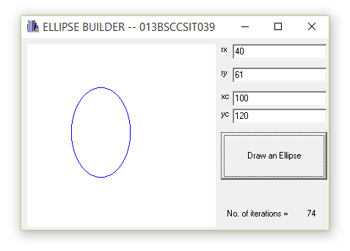

Fig: Drawing a Ellipse with Mid Point Ellipse algorithm

**CONCLUSION:**

The program could plot a simple ellipse with the help of mid point ellipse algorithm. The program needs Radius(Rx and Ry), Xc and Yc co-ordinate values to operate.